PHOENIX ANCIENT ART TO EXHIBIT IN NEW YORK IN OCTOBER AT THE INTERNATIONAL FINE ART & ANTIQUE DEALERS SHOW

Rarities on the stand of Phoenix Ancient Art include:

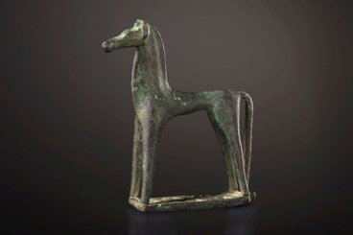

.
A Geometric Horse
Greek, late 8th century B.C.
H: 11 cm, Base: 7 cm (4.3 x 2.8 in.)
Bronze

The horse dates from the Geometric Period, 10th to 8th century B.C. The period was the time great cultural advancement: Homer and the rise of epic poetry and the development of the visual arts. Bronze figurines were produced, depicting people, animals and birds. Representations of horses are among the most familiar symbols in the Geometric iconography. A great number of bronze horses such as this one were used as votive offerings in temples and sanctuaries. This small, stylized, and charming horse is standing upright, his head proudly raised. His chest and neck reveal his .power and his small head is delicately modeled in great detail.

